Composting at School

17361 Block Busters

# Problem

This year Lego teams will have to create a solution for a solid waste problem

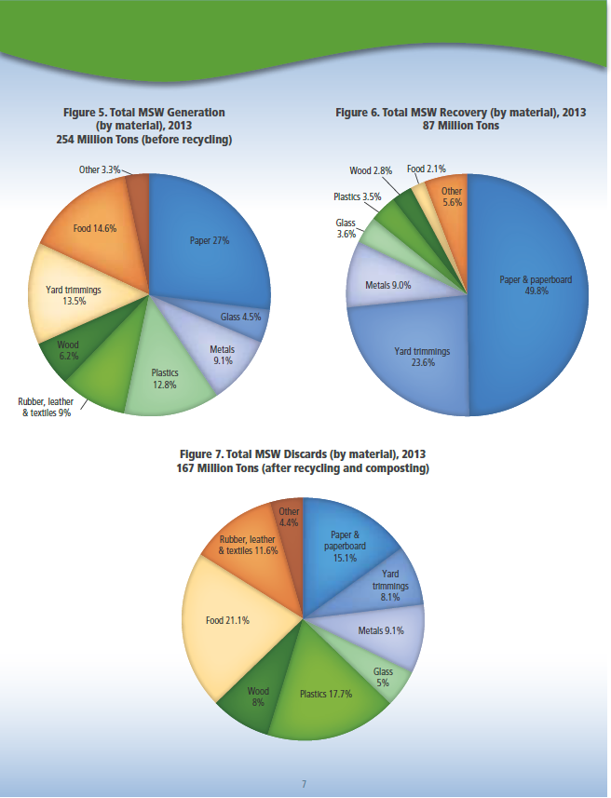Our team noticed that food waste is one of the least reduced kinds of waste. Here is a graph that shows waste that can be recycled. It also shows how much of that kind of waste before it is recycled. Because food waste is not recycled that much the percentage of food waste gets bigger in the final waste stream.

# Background

Our team decided to reduce the food waste problem. After a phone **interview with Brian Raison Director, Community Development, Ohio State University**, we became very excited about food waste at schools and composting.

To find more about composting, we went on a **tour at University of Dayton with Joan Bauman.**

We went in their cafeteria and saw their project in action. We saw some of their compostable plates and silverware. We learned that they pay people to sort through their compost and remove non compostable stuff like wrappers and ketchup packets.

We also saw where they make their compost. It is in the back of the cafeteria in a special room. Our team learned that U.D. pays people to sort the things that is collected in the compost bins

It took U.D. three years to start their compost program.

**We interviewed the Z lab lady Mrs.** **D.** The Z lab is the greenhouse and garden at our school**.** We learned that she really didn’t like sorting through her food compost and having to pick out candy wrappers and other types of trash; that is why she stopped collecting food wasted to compost. To reduce food waste at Miami Valley School we had to come up with a way to compost without having Mrs. D sort it.

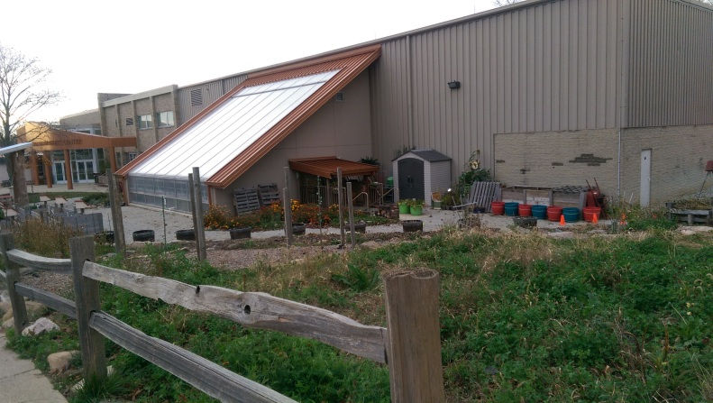

# Solution

The problem to composting in our school appeared to be sorting through the compost and picking out the trash. To solve the problem, we decided to gamify the sorting of compost and make it so students will want to compost. To collect the compost, someone will be selected to go to collect the compost at the end of every day. To notify the lower school, we will talk at an assembly and share our idea with the school.

To make sure the ideas might come to life, we talked to the head of our school, Mr. Jay Scheurle. To make sure the grade knows what to compost, we will put signs up on the compost bins that say what the grade will compost.

At the end of the day, each bag of compost will be checked by someone in the Z lab. If the bag has any non-compostable items the grade does not get a star and the bag is thrown in the trash. There will be no additional sorting to the compost bags. If the bag passes, the grade gets a star.



When the grade gets a certain amount of stars, the grade will get a prize.

Here are some examples of how many stars needed for certain kinds of prizes.

* 10 stars free dress day
* 20 stars extra recess
* 30 stars candy treat
* 50 stars pizza party

After the compost is collected it will be transferred to the Z lab compost bins where it will become nice dirt. The Z lab already has a program for garden waste.

The whole goal of this idea is to teach elementary kids about compost and food waste.

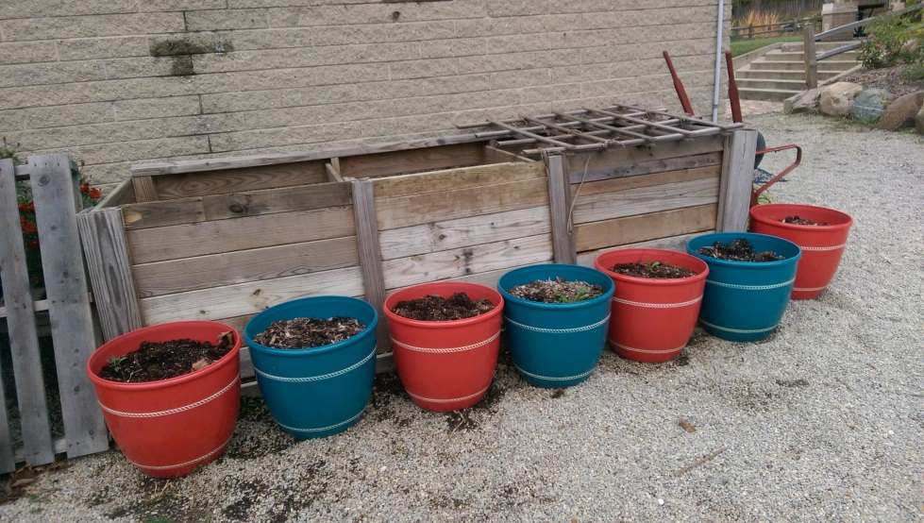

# Conclusion

The clear compostable bags cost 10 cents a bag so if each grade has their own bag and if our school goes through five bags a week, every week will cost around $2.50. So every month will cost $10.00.

It will take about 5 min. each day to check to see if the compost bag is acceptable. It won’t take very long because he/she will only look at it for a short time before deciding if the bag is good or not.